ITI – Java OOP Lab2
Mohammad Tarek Omar – Data Management
Arrays:
- class PositiveNegativeNumsArray
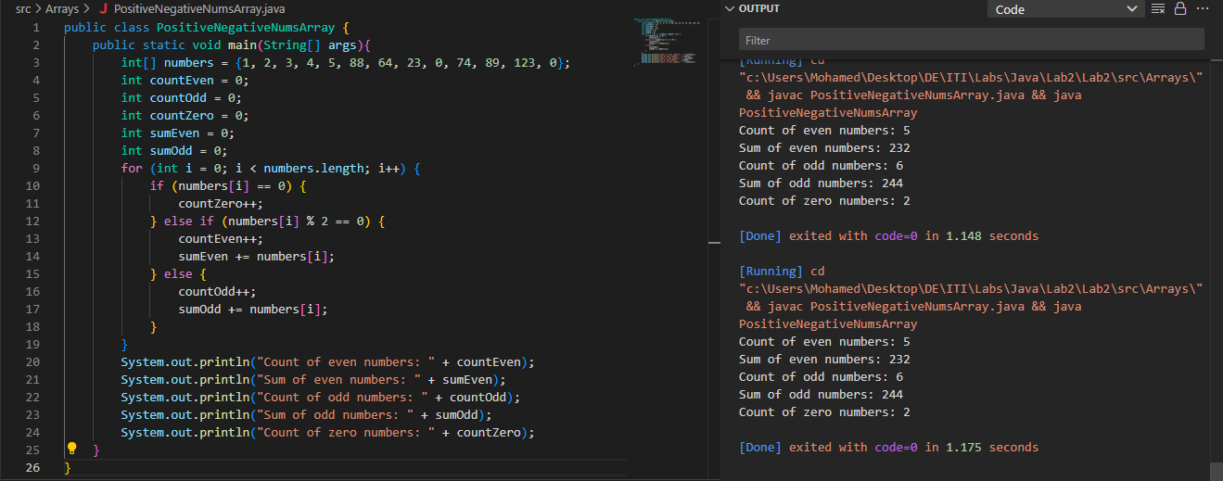
- class ArrayGreaterThanX
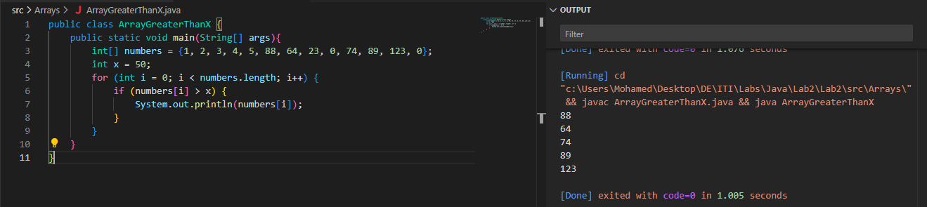
- class ReplaceNegativesWithZero
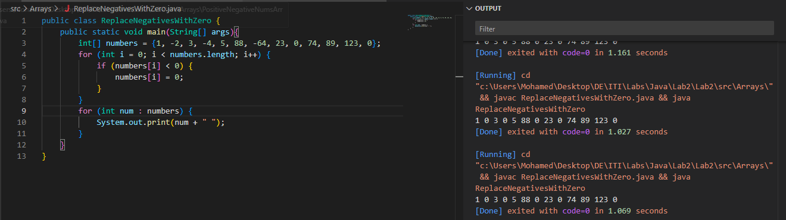

- class CopyArray
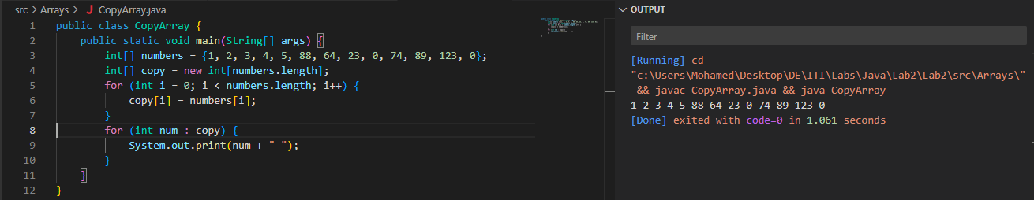
- class FindSecondLargest
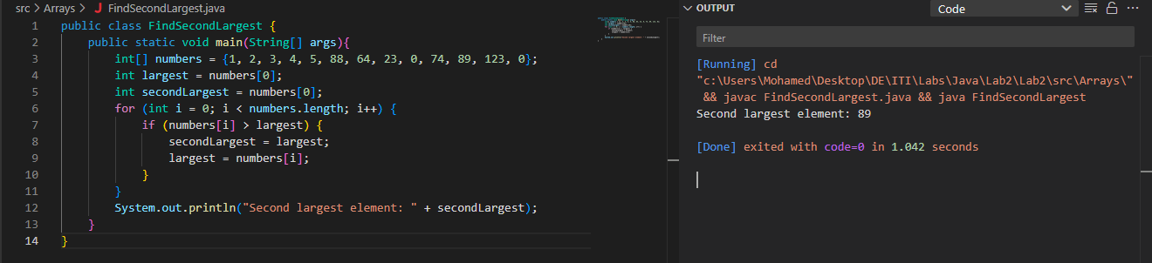
- class ArrayAverageGreaterThanX
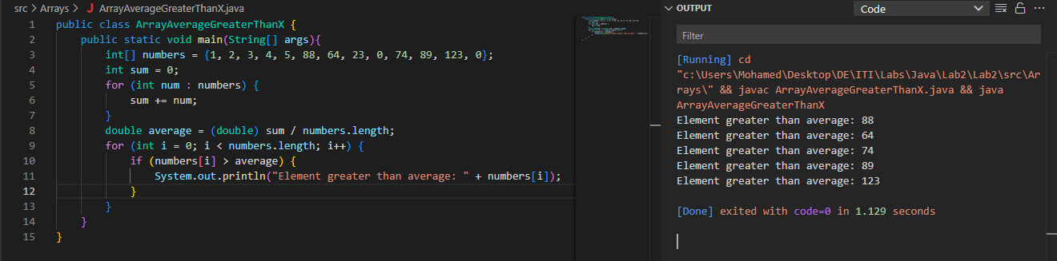
- class SumOfTwoArraysSameIndex
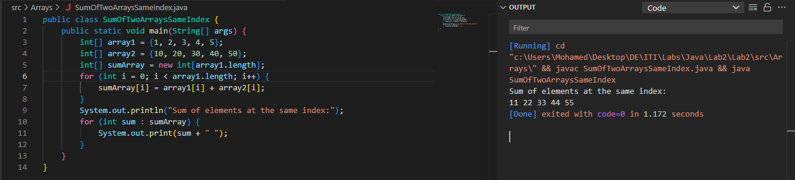

Methods:
- Method to find sum of positive numbers in array - Method to find sum of negative numbers in array
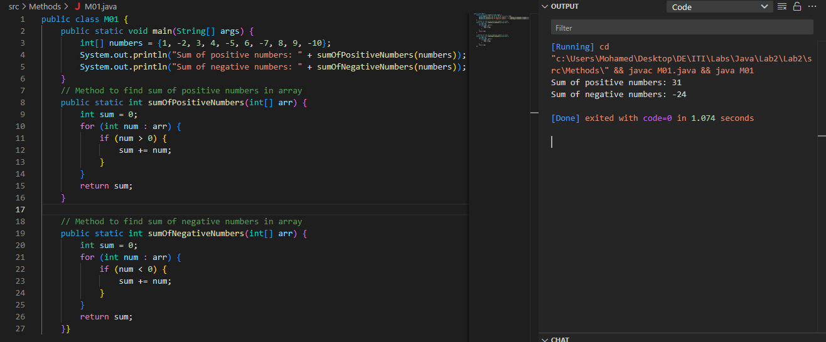
- Method to Find Square of a Number
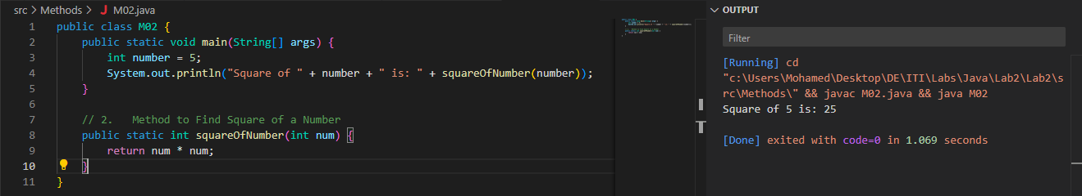
- Method to Calculate Area of Circle
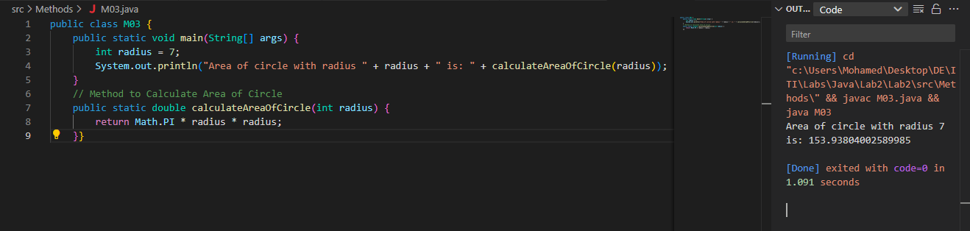
- Method to Check a number if it is a Prime number or not
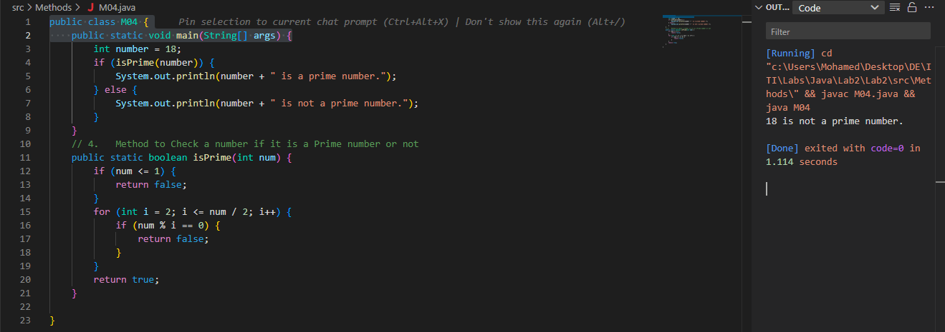
- Method to Check Palindrome Array
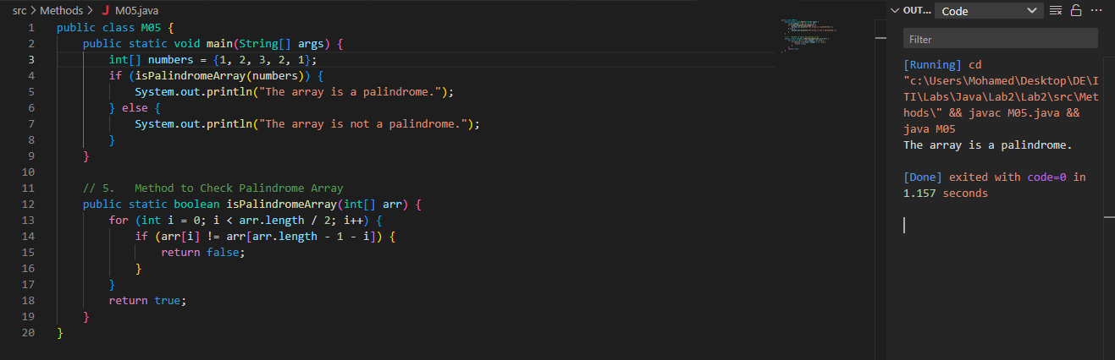
- Method to Find all prime numbers from 1 to 100
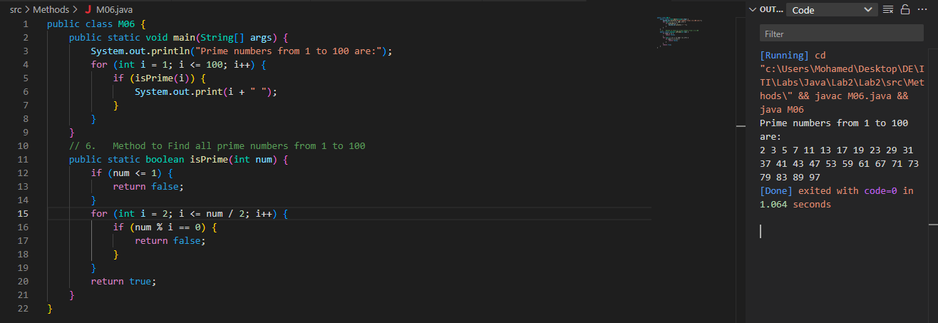

OOP: Create class with 2 different objects – ignore loadDate

